**Dominos - Predictive Purchase Order System**

**Project**

Submitted by-

VenkataSubramanian S

MD112

**Introduction:**

Dominos wants to optimize the process of ordering ingredients by predicting future sales and creating a purchase order. By accurately forecasting sales, Dominos can ensure that it has the right amount of ingredients in stock, minimizing waste and preventing stock outs. This project aims to leverage historical sales data and ingredient information to develop a predictive model and generate an efficient purchase order system.

**Objectives:**

To forecast the pizza sales for a week future and provide an Inventory with Ingredients required for the Pizza sales next week. Also to prepare a Purchase order for the Pizza sales ingredients.

**Libraries Used:**

* Pandas
* Numpy
* Seaborn
* Matplotlib
* Scikit learn
* Statsmodels
* Pmdarima
* Prophet
* Pickle
* Tensorflow
* Holidays
* Itertools
* Datetime

**Datasets:**

**Pizza Sale:**

* Columns:

pizza_id, order_id, pizza_name_id, quantity, order_date, order_time, unit_price, total_price, pizza_size, pizza_category, pizza_ingredients

* Shape:

(48620, 12)

* Description:

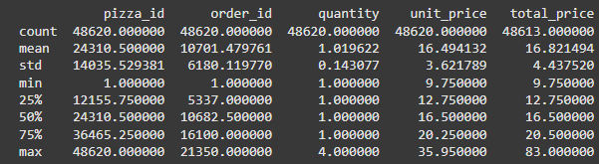

* Info:

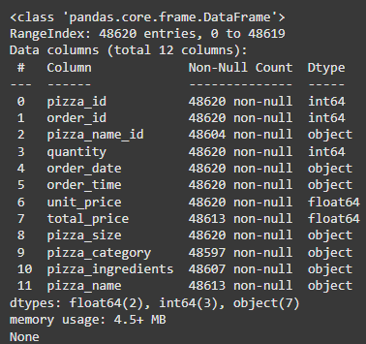

**Pizza Ingredients:**

* Columns:

pizza_name_id, pizza_name, pizza_ingredients, Items_Qty_In_Grams

* Shape:

(518, 4)

* Description:

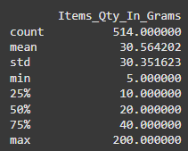

* Info:

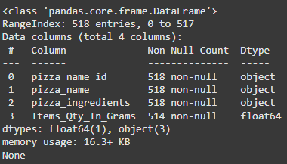

**Data processing:**

The missing values in the Pizza_sales data is filled by the dictionary mapping method and unit price to total price conversion.

The missing values in the Pizza_Ingredients data is filled by the mean of the data.

**Feature Engineering:**

The order date field is split into the Year, Month, Day, Hours, time.

With the help of holidays library, the holiday column is set as True or False if the order date is a holiday

With help of date time, the weekends are calculated and considered as promotional offers days and the Offer columns is set as True or False if the order date is Saturday/Sunday.

We can see that the pizzas are sold highly during the Weekends and Holidays rather normal days.

The most populous Pizza is the California Chicken Pizza with more than 10000 units sold.

The large size pizza is sold mostly.

The pizza sales and ingredients datasets are merged as Merged Dataset for model selection, training and evaluation.

**Models:**

ARIMA Model:

* Weekly pizza sales data frame is created for the ARIMA model training.
* Parameters (p,d,q) : (3,1,5)
* MAPE = 0.1976

SARIMA Model:

* Weekly pizza sales data frame is created for the SARIMA model training.
* MAPE = 0.2327

Prophet Model:

* Daily sales date field is converted to date time using datetime library and Weekly pizza sales data frame is created for the Prophet model training.
* MAPE = 0.2163

Linear Regression Prediction:

* Weekly pizza sales data frame is created for the Linear Regression model training.
* The order date field is split into the week, day, month and year
* The above data is given as input for Linear Prediction model
* MAPE = 0.1906

LSTM Model:

* Weekly pizza sales data frame is created for the LSTM model training.
* The data is normalized using MinMaxScaler
* Input for LSTM model training is created by create_lstm_dataset
* MAPE = 0.2493

**Sales Forecasting:**

From the MAPE scores, we can see that the Linear Regression Prediction model is best.

*prepare_weekly_sales_by_pizza* function returns the quantity of pizza sold in a week by pizza_name_id

*forecast_sales_per_pizza_type_linear_regression* is used to foresee the pizza type and quantity prediction.

*forecast_next_week_sales_by_pizza_type_linear_regression* forecasts the pizza type and quantity prediction for the next 1 week.

The model is then saved as *best_model.pkl*  and can be loaded for future forecasts.

**Ingredient Calculation:**

The *best_model.pkl* is loaded as loaded model

The next 7 days is created as an array using datetime library

The future dates are converted in to a dataframe using *create_regression_features*

The forecasting is predicted using the *best_model.pkl* and the output is mapped as *predicted_quantity* weight in grams.

The ingredients predicted grouped by *pizza_ingredients* is exported as *predicted_ingredient_totals.csv*

**Purchase Order Creation:**

The ingredients predicted is exported as *Predicted Data.csv*

**Conclusion:**

The forecasting model of least MAPE 0.1906 is with the Linear Regression Prediction model. The Purchase order and the Ingredients inventory is exported as part of the project.